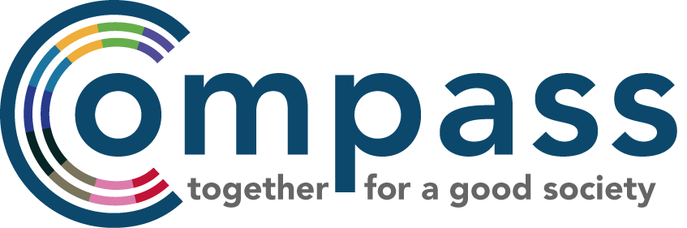

Compass Management Committee FAQs

What does the MC do? The role of the MC is to provide strategic direction for Compass and make decisions on behalf of the membership.

How often do you meet? The MC meet four or five times a year in Vauxhall, London. Meetings are 3 hours long in the afternoon usually on a Monday and we sometimes go to dinner afterwards. We ask MC members to be available for the annual Compass Gathering and Conference as well if they can. We can be flexible to the needs of the MC but generally meetings have been from 2 to 5pm.

What else is involved? We encourage as much active involvement as possible but recognise not everyone can be involved in all of the MC's work outside of meetings. Activity apart from meetings includes helping edit Compass statements for the press, fundraising, having online conversations about key political events and attending Compass events.

How long is the MC term? Each election cycle is two years unless the Compass membership wants to hold an election which is decided at the Gathering. At the Compass Gathering in 2014 it was voted on to extend the MC cycle to every two years to ensure that MC members had enough time to really input on Compass' strategy and priorities.

What are meetings like? We have facilitated meetings and often have a 'chunky item', for example about the current political scene and what Compass should prioritise going into the General Election. We also have conversations about finance, fundraising, projects and how Compass can achieve its aims in a long-term strategic way. Out meetings have a coffee break, nice snacks and is often broken down into participatory formats so that everyone gets a chance to speak.

Who is on the current MC? You can see here for a list of our current MC

What about people who don't live in London? We have current MC members that live in York, North Wales, Scotland and other places outside of London. We encourage a diverse range of people to be on our MC - including regional diversity. We pay any travel expenses and organise all meeting dates at the beginning of the year so people have plenty of time to plan

What skills/ experience do you need to be on the MC? The skills and experience of our MC members varies- from people from the trade union movement, to the green movement, people with skills in fundraising and communications- it really varies. This year we are specifically looking for people with fundraising experience as well as experience in engaging members and activists. Skills and experience aside, what really matters is that you are passionate about Compass' aims and values which you can read more about here.

